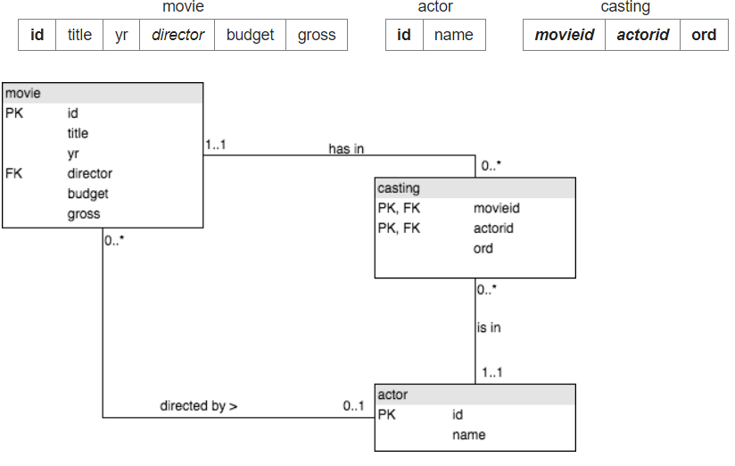

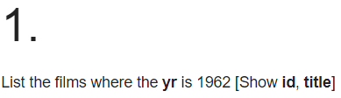

**SELECT id, title FROM movie WHERE yr=1962**

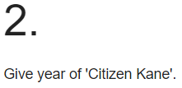

**SELECT yr FROM movie WHERE title = 'Citizen Kane'**

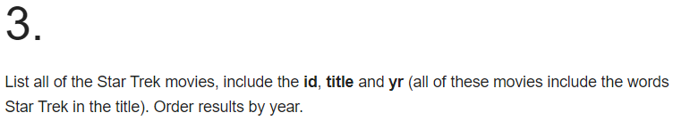

**SELECT id, title, yr FROM movie WHERE title LIKE '%star trek%' ORDER BY yr**

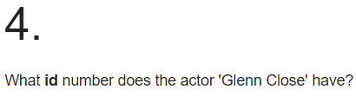

**SELECT id FROM actor WHERE name = 'Glenn Close'**

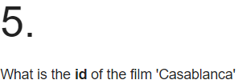

**SELECT id FROM movie WHERE title = 'Casablanca'**

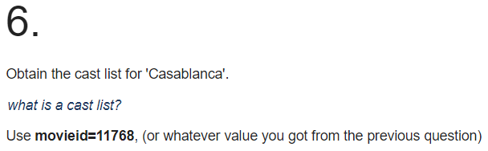

**SELECT name FROM actor, casting WHERE id=actorid AND movieid = (SELECT id FROM movie WHERE title = 'Casablanca')**

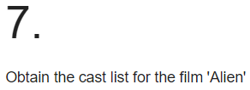

**SELECT name FROM actor JOIN casting ON (id=actorid AND movieid = (SELECT id FROM movie WHERE title = 'Alien'))**

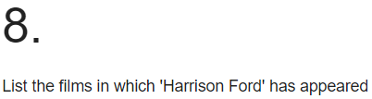

**SELECT title FROM movie JOIN casting ON (id=movieid AND actorid = (SELECT id FROM actor WHERE name = 'Harrison Ford'))**

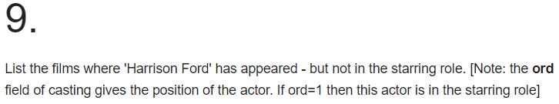

**SELECT title FROM movie JOIN casting ON (id=movieid AND actorid = (SELECT id FROM actor WHERE name = 'Harrison Ford') AND ord != 1)**

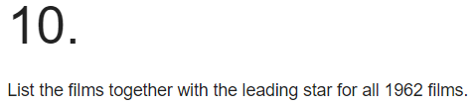

**SELECT title, name FROM movie JOIN casting ON (id=movieid) JOIN actor ON (actor.id = actorid) WHERE ord=1 AND yr = 1962**